**DAILY ONLINE ACTIVITIES SUMMARY**

|  |  |  |  |  |  |  |  |
| --- | --- | --- | --- | --- | --- | --- | --- |
| **Date:** | **17/07/2020** | | | | **Name:** | **Niharika G V** | |
| **Sem & Sec** | **8th sem, A sec** | | | | **USN:** | **4AL16CS059** | |
| **Online Test Summary** | | | | | | | |
| **Subject** | | **NA** | | | | | |
| **Max. Marks** | |  | | **Score** | |  | |
| **Certification Course Summary** | | | | | | | |
| **Course** | **Introduction to Digital Marketing** | | | | | | |
| **Certificate Provider** | | | **Great Learning** | **Duration** | | | **2.5 hrs** |
| **Coding Challenges** | | | | | | | |
| **Problem Statement: Java Program to break integer into digits**  **{**  **// Method 1: Using String object**  **char[] ch = {'g', 'o', 'o', 'd', ' ', 'm', 'o', 'r', 'n', 'i', 'n', 'g'};**  **String str = new String(ch);**  **System.out.println(str);**    **// Method 2: Using valueOf method**  **String str2 = String.valueOf(ch);**  **System.out.println(str2);**  **}**  **}** | | | | | | | |
| **Status: Completed** | | | | | | | |
| **Uploaded the report in Github** | | | | **Yes** | | | |
| **If yes Repository name** | | | | **Daily_progress** | | | |
| **Uploaded the report in slack** | | | | **Yes** | | | |

Online Test Details: No test conducted

Certification Course Details:

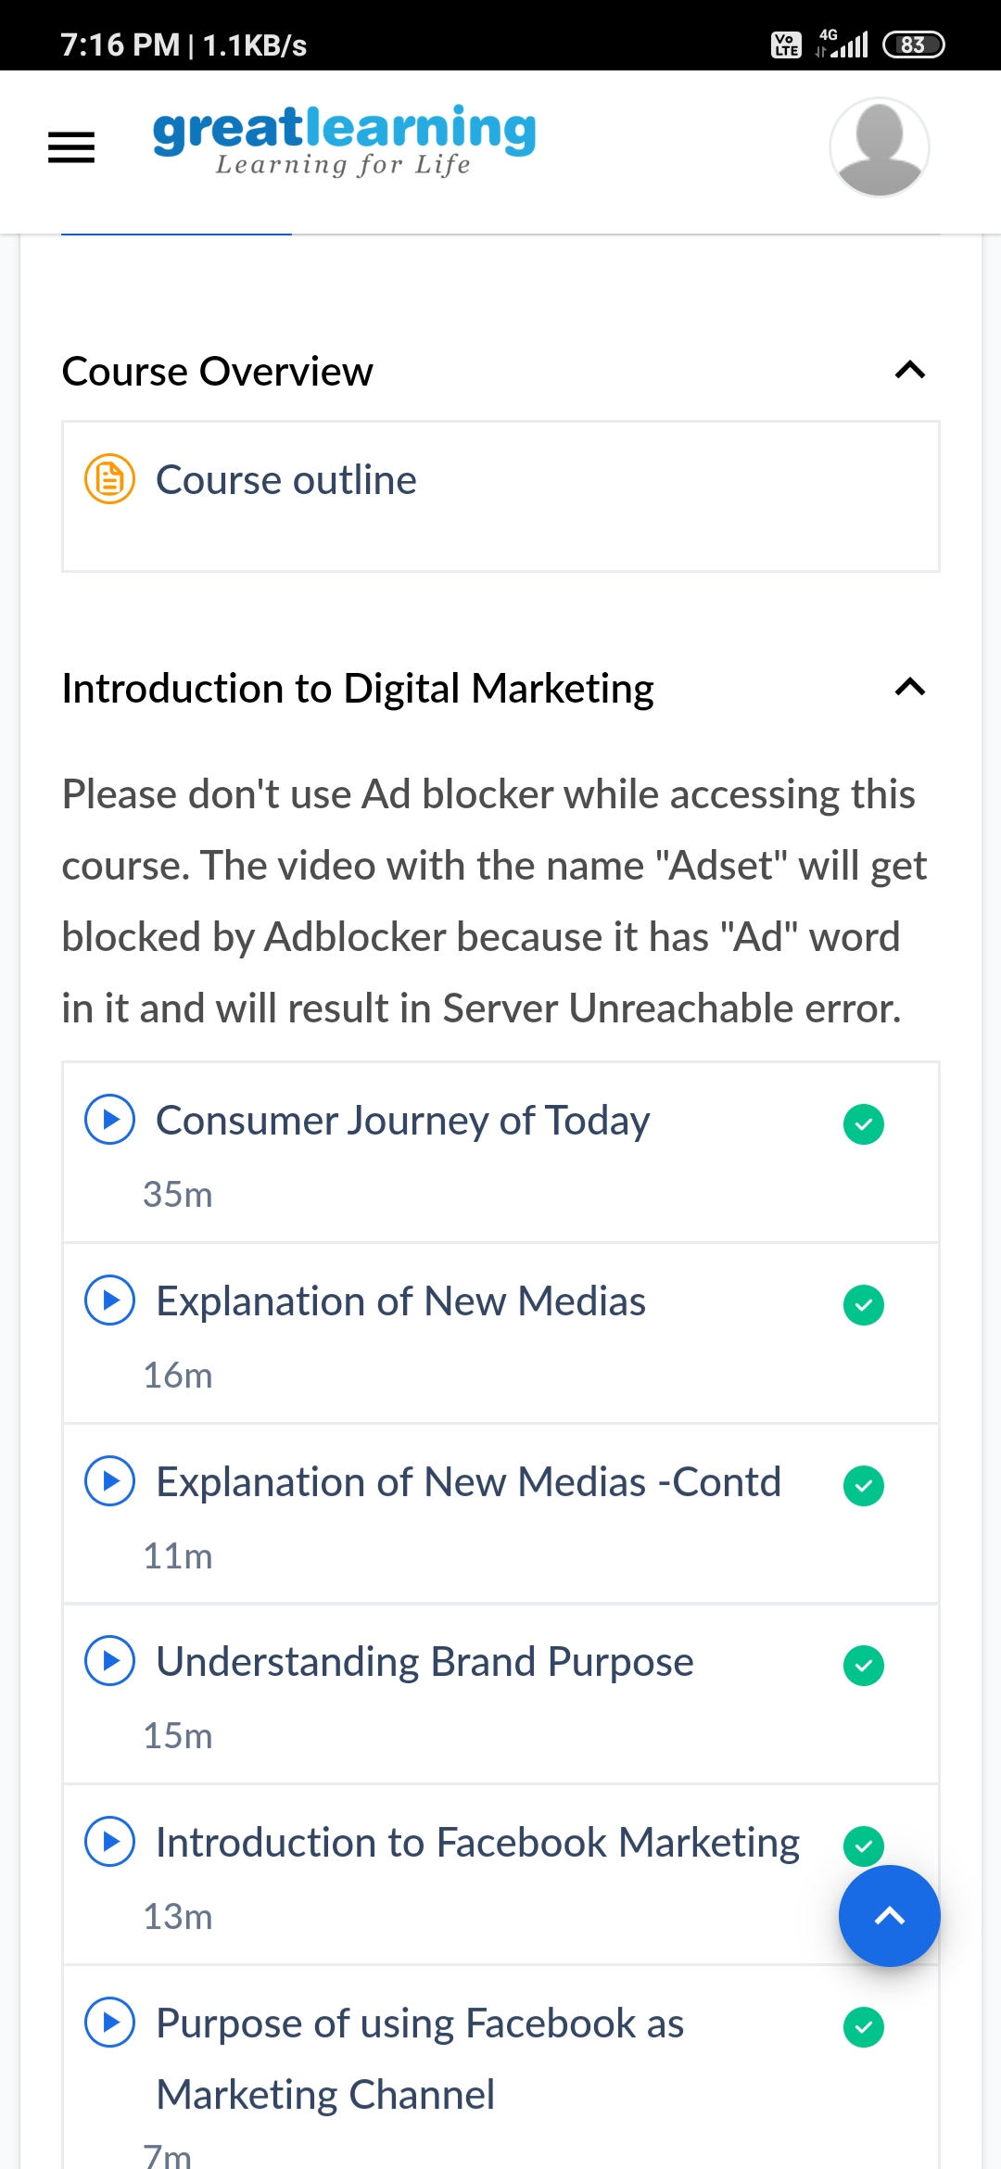

Coding Challenges Details:

import java.util.Scanner;

public class JavaExample

{

public static void main(String[] args)

{

int count;

String temp;

Scanner scan = new Scanner(System.in);

//User will be asked to enter the count of strings

System.out.print("Enter number of strings you would like to enter:");

count = scan.nextInt();

String str[] = new String[count];

Scanner scan2 = new Scanner(System.in);

//User is entering the strings and they are stored in an array

System.out.println("Enter the Strings one by one:");

for(int i = 0; i < count; i++)

{

str[i] = scan2.nextLine();

}

scan.close();

scan2.close();

//Sorting the strings

for (int i = 0; i < count; i++)

{

for (int j = i + 1; j < count; j++) {

if (str[i].compareTo(str[j])>0)

{

temp = str[i];

str[i] = str[j];

str[j] = temp;

}

}

}

//Displaying the strings after sorting them based on alphabetical order

System.out.print("Strings in Sorted Order:");

for (int i = 0; i <= count - 1; i++)

{

System.out.print(str[i] + ", ");

}

}

}